THE TITLE OF THE THESIS WILL BE IN CAPITAL LETTERS, DOUBLE SPACED AND IN AN INVERTED PYRAMID FORMAT IF TITLE
IS MORE THAN ONE LINE LONG

by

AUTHOR’S NAME

THESIS
Presented to the Directors of the
UTSA RISE (or MARC) Program
The University of Texas at San Antonio
In Partial Fulfillment
Of the Requirements
For Successful Completion of the

UTSA Research Initiative for Scientific Enhancement
Research training Program
Or
UTSA Maximizing Access to Research Careers
Research Training Program

THE UNIVERSITY OF TEXAS AT SAN ANTONIO
Name of College
Name of Department
Month and Year of Graduation

Put your same title here again, making sure that it’s in all caps and in an inverted pyramid format if it’s
more than one line long.

To use the same thesis for the Honors College, you can swap out this page and then just replace it with the one from Honors, that has Richard Diem’s signature…
PREPARED BY:

____________________________________
Your full name

APPROVED BY:

____________________________________
Advisor’s Name, Ph.D., Thesis Advisor

____________________________________
Reader’s Name, Ph.D., Thesis Reader

____________________________________
Reader’s Name, Ph.D., Thesis Reader

Accepted: ___________________________________
Dr. Edwin Barea-Rodriguez, PD MARC U*STAR

Received by MARC U*STAR

________Date________

Acknowledgements
Indent this paragraph. Here thank everyone who as assisted you. People often focus on their family in one section, and then professional assistance provided by academic personnel, agencies and institutions. You should also mention your funding. (RISE GM 60655 or MARC U*STAR GM 07717, etc). It can be multiple paragraphs but only one page long.

ABSTRACT

Put your same title here again, making sure that it’s in all caps and in an inverted pyramid format if it’s
more than one line long.
Student’s name, B.S.
The University of Texas at San Antonio, 2008

Supervising Professor: John Doe, Ph.D.
Indent paragraph. Put an abstract here of between 150 and 300 words. This is like your abstracts that you sent to conferences, but will encompass a larger topic. Make sure to include an introduction, a statement of problem, a hypothesis, brief methods, a summary of your findings, conclusions with importance of the work stated. You don’t need to put citations in this part, but could if you want.

TABLE OF CONTENTS
Acknowledgements iv
ABSTRACT iv
CHAPTER 1: INTRODUCTION 1
CHAPTER 2: THESIS STATEMENT 3
2.1 Hypothesis 1 3
2.2 Hypothesis 2 3
2.3 Hypothesis 3 3
CHAPTER 3: METHODS AND APPROACH 4
3.1 Experimental design 4
3.2 Techniques employed 4
3.3 Statistical analysis 4
3.4 Limitations of Methods and Approach 4
CHAPTER 4: RESULTS 5
4.1 Isolation of viral genome 5
4.2 Transformation and Amplification of genome 5
4.3 Sequence Analysis of Genome 5
4.2 Viral Re-expression in a Host 5
This is the Honors College example that I’ve messed with. It’s neat because it somehow right justifies all of the numbers and keeps them aligned on the right. You can change the text as needed to have the subheadings that you need for your work. You can also copy and paste whole lines to make more of these formatted sections, if you need more subheadings in any sections. For example, you might have only one hypothesis, you might have different subheadings in Chapter 3 and 4. In Results, each experiment can be a subheading. Use the subheadings commonly used in papers on topics similar to yours.
CHAPTER 5: Discussion 6
CHAPTER 6: IMPLICATIONS and future directions 7
REFERENCES 8
APPENDICES 9

Chapter 1: Introduction
This is your standard scientific intro. Indent each paragraph. Put lots of citations in it.

Chapter 2: Thesis Statements
The purpose of this project is to _______. To carry it out, we will accomplish the following Specific Aim (or Goal). We hypothesize that __________________________.

Chapter 3: Methods and Approach
Insert methods here. Subdivide as needed but reflect it in the TOC above. Lorem ipsum dolor sit amet, consectetur adipisicing elit, sed do eiusmod tempor incididunt ut labore et dolore magna aliqua. Ut enim ad minim veniam, quis nostrud exercitation ullamco laboris nisi ut aliquip ex ea commodo consequat. Duis aute irure dolor in reprehenderit in voluptate velit esse cillum dolore eu fugiat nulla pariatur. Excepteur sint occaecat cupidatat non proident, sunt in culpa qui officia deserunt mollit anim id est laborum.

3.1 Experimental Design
Lorem ipsum dolor sit amet, consectetur adipisicing elit, sed do eiusmod tempor incididunt ut labore et dolore magna aliqua. Ut enim ad minim veniam, quis nostrud exercitation ullamco laboris nisi ut aliqu

3.2 Techniques Used (and can even subdivide this if needed or desired)

CHAPTER 4: RESULTS
Type results here. It’s easiest if you’ve decided what figures that you and your mentor will be making and then insert them and write around them to describe them. NOTE: YOU WILL NEED TO PUT A SEPARATE SINGLE SPACED FIGURE LEGEND/DESCRIPTION NEAR EACH FIGURE, JUST LIKE YOU SEE IN SCIENTIFIC PAPERS. It takes a bit of geeking in Word, but it’s very possible (If I did it in 1995, you certainly can do it now…). You will also subdivide this as you’ve subdivided the TOC, into individual experimental sections.
Partial example:
β-galactosidase Assay
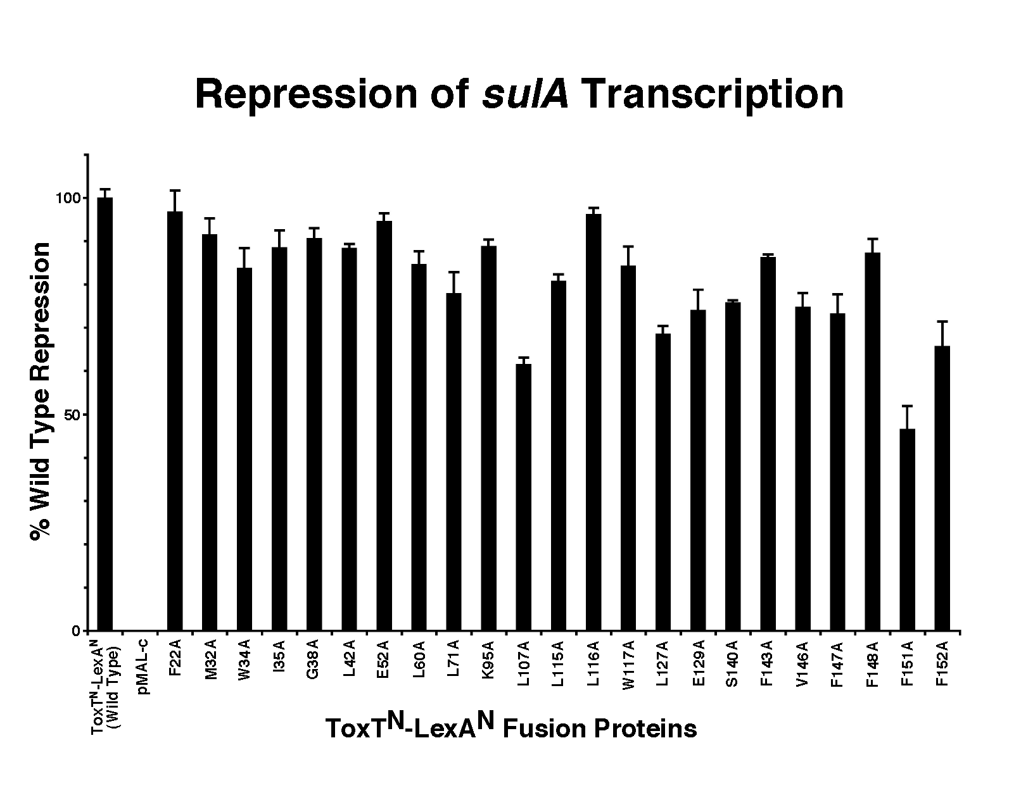
Figure 2. β-galactosidase Assay. Twenty-three N-terminal mutations assayed for β-galactosidase activity. Of the twenty-three, only two are statistically critical for dimerization: F151A (p < 0.001) and L107A (p < 0.001).

β-galactosidase assays indicated that amino acids located in the predicted beta jelly roll (aa 1-87) were found to exhibit wild type repression by 75% or more (Figure 2). Amino acids in the two alpha helical regions (alpha helix 1: aa 88-98, alpha helix 2: aa 99-165) displayed variable wild type repression ranging from less than 50% to nearly 100%. Student t-test indicates that F151A (p < 0.001) and L107A (p < 0.001) significantly affect ToxT dimerization (Figure 2). Interestingly, these amino acids lie within the predicted dimerization interface (alpha helix two) of ToxT, as illustrated by the structural model of AraC (Figure 1).

CHAPTER 5: DISCUSSION
Standard discussion here. Initially swing back to major results and summarize them in the first paragraph. Then go experiment by experiment and discuss what each demonstrated and how it was expected or not and how it relates to the literature. Then discuss what the entire group of experiments demonstrated and how it relates to the literature. Swing back and discuss what happened with your hypotheses…were they supported?

cHAPTER 6: iMPLICATIONS AND fUTURE dIRECTIONS
Why is your stuff important to the world? This is often part of the discussion, but split out here for this section.

References
Reference list/style should follow the format of a peer-reviewed journal for your academic discipline

AASHTO 2004. “AASHTO LRFD Bridge Design Specifications,” American Association of State Highway and Transportation Officials, 3rd edition, Washington, D.C.

Aswad, A., and Chen, Y., “Impact of LRFD Specification of Load Distribution of PS Concrete Beams,” PCI Journal, V. 39, No., September-October 1994, pp78-89

Aswad, G., “Comparison of Refined and simplified Analysis Methods for PS Concrete I-Beam Bridge Decks,” MSc Thesis, University of Colorado at Denver, Denver, CO, 1994

AppendiCes
If you have more than one appendix, label them A, B and C and list them here like you did the figure and tables pages. Then label them well and put them afterwards. If there is only one, then just put it here.

