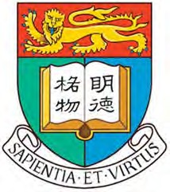

The 1st Symposium of Metal-Carbene Consortium

T6, Meng Wah Complex
P1, CYM Chemistry Building
- December, 2016
- December, 2016

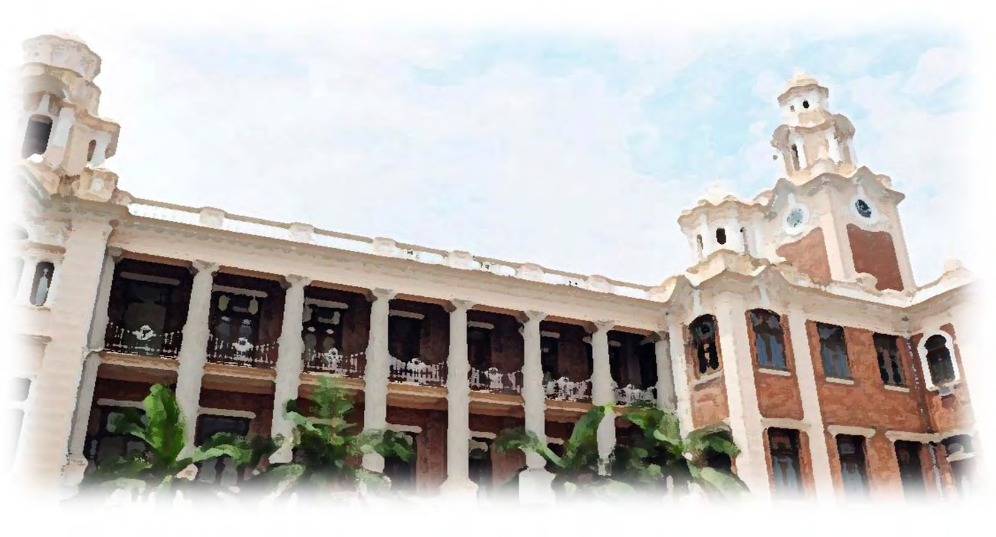

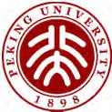
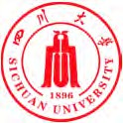
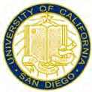
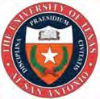
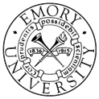

Organized by
State Key Laboratory of Synthetic Chemistry, Department of Chemistry, The University of Hong Kong

Scientific Program

Thursday, 1 December 2016

Venue: Lecture theater T6, Meng Wah Complex

10:45 – 11:00 Opening Remarks: Prof. Chi-Ming Che (HKU)

Session 1 (11:00 – 12:30) Chair: Prof. Chi-Ming Che (HKU) 11:00 – 11:30 Prof. Michael P. Doyle (UTSA)
Asymmetric Cycloaddition Reactions with Metal Carbenes

11:30 – 12:00 Prof. Jianbo Wang (PKU)
Transition Metal Catalyzed Cross-Couplings with Carbene Precursors

12:00 – 12:30 Prof. Pauline Chiu (HKU)
Synthetic Studies towards Welwistatin Based on a Rhodium Carbene Rearrangement Reaction

12:30 – 14:00 Lunch Break

Session 2 (14:00 – 15:00) Chair: Dr. Man-Kin Wong (PolyU) 14:00 – 14:30 Prof. Xiaoming Feng (Sichuan U)
Asymmetric X-H Bonds Insertion with α-Diazoesters

14:30 – 15:00 Prof. Michael Fuk-Yee Kwong (PolyU)
Palladium-Catalyzed Three-Component Synthesis of Phenanthrene Derivatives: A Combination of C-H bond Activation, Decarboxylation and retro-Diels-Alder Strategy

15:00 – 15:30 Coffee Break

Session 3 (15:30 – 17:00) Chair: Prof. Pauline Chiu (HKU) 15:30 – 16:00 Prof. Guy Bertrand (UCSD)
Coordination Chemistry and Catalysis with Novel Types of Carbenes

16:00 – 16:30 Dr. Cong-Ying Zhou (HKU)
Transition Metal Porphyrin Catalyzed Alkylcarbene Transfer Reactions

16:30 – 17:00 Prof. Vivian Wing-Wah Yam (HKU)
Versatile Chromophores and Excited States - From Fundamentals to Supramolecular Assembly and Photofunctions

Close of the First Day

Friday, 2 December 2016

Venue: Lecture theatre P1, CYM Chemistry Building

Session 4 (10:30 – 12:00) Chair: Prof. Michael Fuk-Yee Kwong (PolyU) 10:30 – 11:00 Prof. Huw M. L. Davies (Emory)
Catalyst-Controlled Selective Functionalization of Unactivated C-H Bonds

11:00 – 11:30 Prof. Zuowei Xie (CUHK)
Stabilization of Reactive Boron Compounds by Carbenes: Synthesis, Structure and Reactivity

11:30 – 12:00 Prof. Chi-Ming Che (HKU)
Anti-Cancer Metal-NHC Complexes

12:00 – 14:00 Lunch Break

Session 5 (14:00 – 15:40) Chair: Dr. Cong-Ying Zhou (HKU) 14:00 – 14:30 Dr. Michael Wing-Yiu Yu (PolyU)
Cascade Functionalization on Carbenoid Carbon. Catalytic Cross Coupling via Carbene Migratory Insertion

14:30 – 15:00 Dr. Sharon Lai-Fung Chan (PolyU)
Synthesis and Application of Ruthenium Complexes supported by Fischer-type Carbene Chromophore

15:00 – 15:20 Mr. Haixu Wang (HKU)
Cobalt Porphyrin-Catalyzed Intramolecular Buchner Reaction/Arene Cyclopropanation of Alkylcarbene

15:20 – 15:40 Mr. Jieren Deng (PolyU)
Combining Gold, Silver and Visible Light Mediated Catalysis for Bioconjugation and Molecular Imaging

15:40 – 16:10 Coffee Break

Session 6 (16:10 – 17:10) Chair: Dr. Sharon Lai-Fung Chan (PolyU) 16:10 – 16:30 Ms. Hairong Lyu (CUHK)
Transition Metal Catalyzed Regioselective B-H Activation and Functionalization of o-Carboranes

16:30 – 16:50 Mr. Chun-Kit Li (PolyU)
Catalytic C-H Bond Functionalization for C-C and C-N Bond Formation. A Expedient Approach for Anthranilic Acids Synthesis

16:50 – 17:10 Dr. Taotao Zou (HKU)
Gold(III), Gold(I) and Platinum(II) Containing N-Heterocyclic Carbene Ligands: Anti-Cancer Agents and Luminescent Diagnostic Agents
17:10 – 17:20 Closing Remarks: Prof. Michael Fuk-Yee Kwong (PolyU) Close of the Symposium

