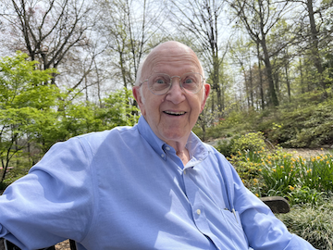
In Memoriam: Professor Michael P. Doyle

The UT San Antonio community mourns the passing of Professor Michael P. Doyle, a distinguished organic chemist, educator, and mentor whose career shaped generations of scientists and advanced the field of chemistry worldwide.

Professor Doyle held faculty and leadership positions at Hope College, Trinity University, the University of Arizona, the University of Maryland-College Park, and ultimately UT San Antonio, where he served as the Rita and John Feik Distinguished University Chair in Medicinal Chemistry. Internationally recognized for his groundbreaking work in enantioselective catalysis—including the eponymous Doyle–Kirmse reaction—he authored hundreds of publications, patents, books, and book chapters, and was a Fellow of both the American Chemical Society and the Royal Society of Chemistry.

Above all, Prof. Doyle’s greatest passion was training undergraduates in organic chemistry. Over the course of his career, he mentored hundreds of undergraduate researchers, more than 150 of whom became co-authors on scientific publications and went on to impactful careers of their own. He often said that mentoring students was what he was most proud of, and his commitment to undergraduate research left an indelible mark on chemistry education nationwide.

To honor this commitment, Professor Doyle and his wife, Janice, established a scholarship fund to provide summer financial support for undergraduate research students. Those wishing to honor his memory are invited to contribute to this fund at https://engage.utsa.edu/Doyle

Professor Doyle’s legacy lives on through the students he trained, the colleagues he inspired, and the scientific community he helped build.

