To check if your PDF is accessible:

- Open the PDF in Adobe
- Click on the “All Tools” tab at the top
- Select “Prepare for accessibility”
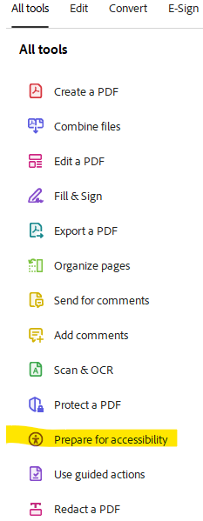
- Select “Check for accessibility”
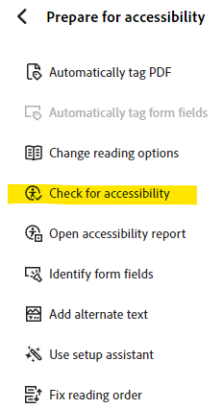
- A box will pop up – check the “Start Checking” tab at the bottom
- An Accessibility Checker box will open on the right
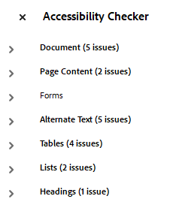
- Click on each section with issues and fix the errors
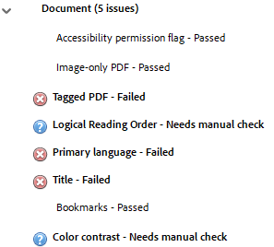
- right click on the error and you will be given options
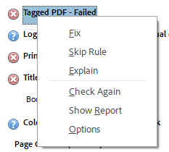
  - If “Fix” is an option, selecting it will correct the issue (or give you an option to select that will fix the issue)
  - If “Fix” is not an option, select “Explain” and you will be taken to Adobe Help that will explain what you need to do to fix the issue
- After everything is fixed, save the PDF

